CIVE 625 – Quantitative Ecohydrology
Homework 1 (Due Feb 2nd 2024)

Problem 1 (25 pt) Assume the air temperature to be 32 ºC and the relative humidity 50%, the air pressure is at 95 kPa. Compute the following variables:

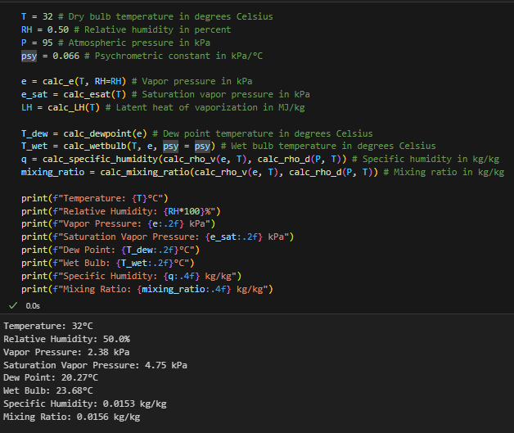
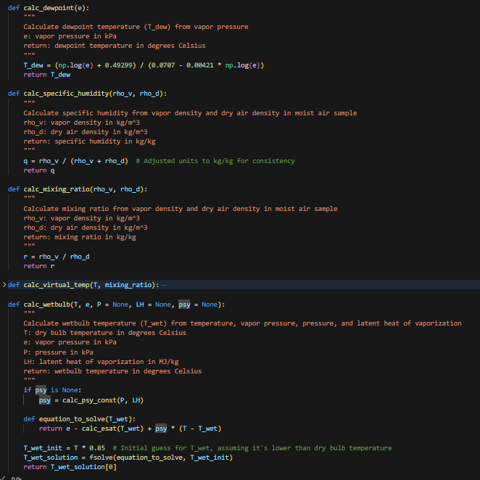

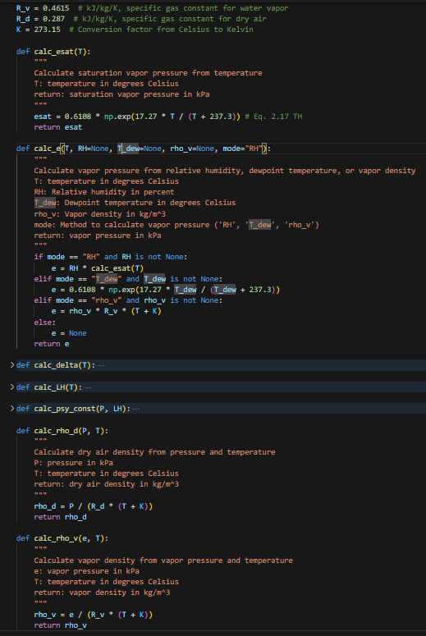

- If the air cools at night to 18 ºC, will fog form near the surface?
- Yes because 18 C is below the dew point temperature of 20.3 C.

Problem 4 (20 pt) The following data are averages for a typical summer day in a temperate climate: air temperature, T_{a} = 17.94ºC; relative humidity, 66%; and incoming, short-wave radiation, S_{in} = 468 cal cm⁻² d⁻¹. Calculate the net radiation, R_{n} (in W m⁻²), for a surface covered with short vegetation. Assume that the daily average of the surface temperature, T_{s}, is the same as the air temperature, and that cloudiness does not affect the long-wave radiation, when it is derived from T_{a}.
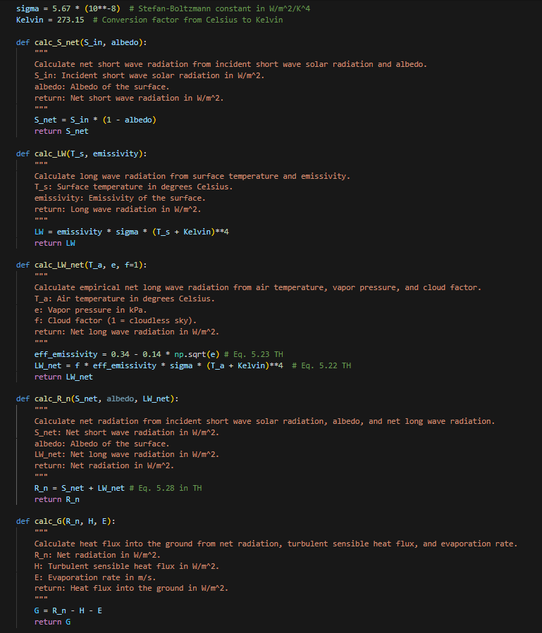

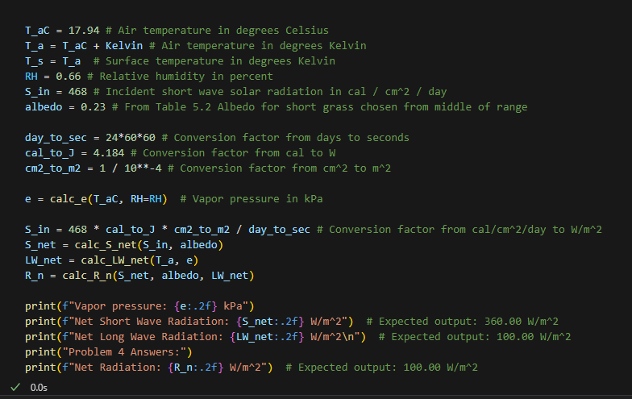

Problem 5 (15 pt) Consider the following observations: net radiation R_{n} = 200 Wm⁻²; heat flux into the ground, G = 40 Wm⁻²; and evaporation rate, E = 5 10⁻⁸ ms⁻¹.
- Calculate the turbulent sensible heat flux, H, in Wm⁻²

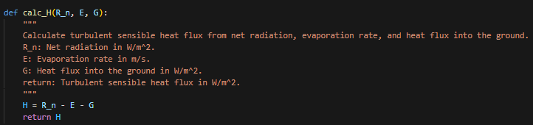
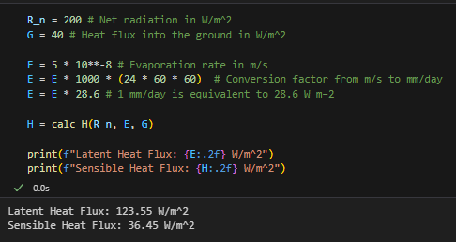

- Was the atmosphere stable or unstable? Why?
  - The atmosphere is unstable because the net radiation is positive, which means the surface is warmer than the air above it. This will cause the air to rise and the atmosphere to be unstable.
  - 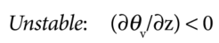
  - 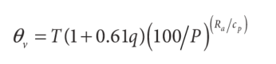
  - 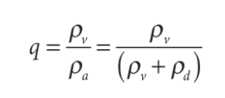
  - 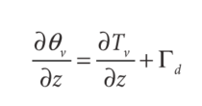
  - 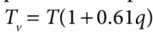
- Was the soil warming up or cooling down? Why?
  - The soil is warming up because the net radiation is positive and the heat flux into the ground is positive.

